भारतमौसमविज्ञानविभाग |  | India Meteorological Department
Sunday, 22nd June 2025 (1st Ashadha 1947 Saka)
Summary of observations recorded at 0830 hours IST: Southwest monsoon has further advanced over most parts of Himachal Pradesh, entire Ladakh, most parts of Jammu & Kashmir and some parts of Punjab. The Northern Limit of Monsoon passes through 25.0°N/60.0°E, 25.0°N/65.0°E, 25.5°N/70.0°E, Jaipur, Agra, Rampur, Dehradun, Shimla, Pathankot, Jammu, and 33.5°N/73.0°E and 34.0°N/71.0°E. Conditions are favourable for further advance of Southwest monsoon over remaining parts of North Arabian Sea, some more parts of Rajasthan, Punjab, some parts of Haryana, Chandigarh and Delhi, remaining parts of West Uttar Pradesh, Himachal Pradesh and remaining parts of Jammu during next 2 days. The low-pressure area over southwest Bihar & neighbourhood moved west-northwestwards & lay over southeast Uttar Pradesh & neighbourhood at 0530 hrs IST of today, the 22nd June 2025. It then lay over central parts of south Uttar Pradesh at 0830 hrs IST of today, the 22nd June 2025. The associated upper air cyclonic circulation extended upto 5.8 km above m. s. l. tilting southwards with height. It is likely to move slowly northwestwards and weaken gradually during next 12 hours. An upper air cyclonic circulation lies over Bangladesh and adjoining Gangetic West Bengal between 1.5 & 5.8 km tilting southwards with height. The trough from central Pakistan to cyclonic circulation over central Assam at 1.5 km above m. s. l. now lay as east-west shear line/trough from south Pakistan to above cyclonic circulation over Bangladesh and adjoining Gangetic West Bengal across central parts of Rajasthan, northwest Madhya Pradesh, cyclonic circulation associated with low pressure area over central parts of south Uttar Pradesh & neighbourhood and Jharkhand between 1.5 & 4.5 km above mean sea level tilting southwards with height. The trough from south Gujarat region to northeast Bangladesh at 3.1 km above m. s. l. merged with the above trough. An upper air cyclonic circulation lay over northeast Assam & neighbourhood at 0.9 km above m. s. l. An upper air cyclonic circulation likely to form over Gangetic West Bengal & neighbourhood around 25th June. The cyclonic circulation over northeast Rajasthan & neighbourhood became less marked. The upper air cyclonic circulation over central parts of Assam became less marked.
Day temperatures were markedly above normal (> 5.1°C) at few places over Jammu-Kashmir-Ladakh-Gilgit-Baltistan-Muzaffarabad; at isolated places over Odisha. appreciably above normal (3.1°C to 5.0°C) at isolated places over Assam & Meghalaya, sub Himalayan West Bengal & Sikkim, Himachal Pradesh, Chhattisgarh, coastal Andhra Pradesh & Yanam, Tamil Nadu, Puducherry & Karaikal and Kerala & Mahe. above normal (1.6°C to 3.0°C) at many places over Telangana and coastal Karnataka; at few places over Arunachal Pradesh, Nagaland, Manipur, Mizoram & Tripura and Vidarbha; at isolated places over Konkan & Goa, Rayalaseema. near normal (-1.5°C to 1.5°C) at many places over Uttarakhand; at most places over Gangetic West Bengal, Madhya Maharashtra, Marathwada, north interior Karnataka, south interior Karnataka and Lakshadweep; at few places over Jharkhand, Bihar, east Uttar Pradesh, west Uttar Pradesh, Haryana-Chandigarh-Delhi, Punjab, West Rajasthan and Saurashtra & Kutch; at isolated places over Andaman & Nicobar Islands and east Rajasthan. Yesterday, the highest maximum temperature of 42.3°C was reported at Sriganganagar (Rajasthan).
The Southwest Monsoon has been Vigorous over east Madhya Pradesh and It has been subdued over Odisha, Chhattisgarh and Rayalaseema.
Total 322 Station reported rainfall today. Total rainfall is 262.2 cm. Total 310 station reported rainfall today whose normals are available. Total rainfall is 251.2 cm with normal station total is 244.3 cm.
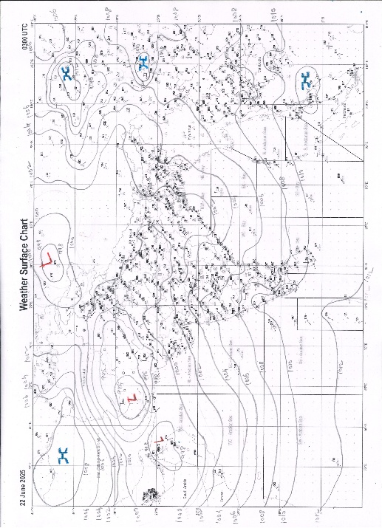 | 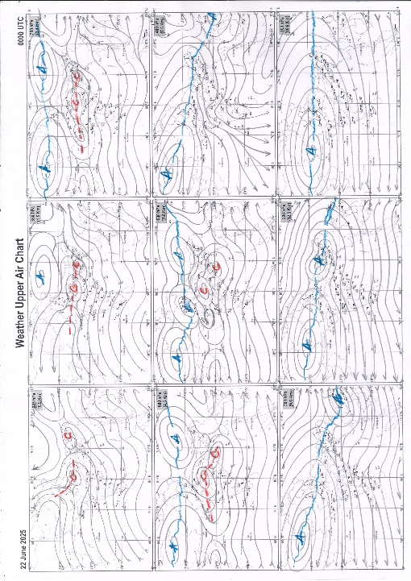
g.1. Analysed surface chart based on 03z observation | Fig.2. Analysed upper air chart based on 00z observation

Dr. S.D.Sanap
Scientist ‘D’
CR & S Office, Pune  Issued at 1245 hrs. IST |  | Weather Forecasting Division  CR&S, Pune

Indian regions | Realised rainfall (chief amount in cm during past 24 hrs):
East | most places: Sub-Himalayan West Bengal & Sikkim+++  a few places: Assam & Meghalaya+, Nagaland-Manipur-Mizoram-Tripura, Odisha and Bihar+++  isolated places: Arunachal Pradesh, Gangetic West Bengal+ and Jharkhand  Toorsa tea garden 16.0, Sheohar 13.2, Tezpur 8.6, Hasimara 8.0, Araria 7.8, Maynaguri college 7.4, Bhaghmara 7.1, Bhumuraguri 6.7, Harinkhola 6.5, Tangi 6.2, Dhenkanal PTO 4.7, Ukhrul 4.2, Zrs dumka 3.7, Bankura (CWC) 3.2, Ramgarh dvc 3.1, Bankura 2.7, Kiphire & Paradeep cwr 2.6 each, Naharlagun 2.1, Patna aerodrome 2.0, Kohima 1.5, Hawai 1.4, Bomdila 0.2.
North | many places: east Rajasthan+++  a few places: east Uttar Pradesh+ and west Rajasthan  isolated places: west Uttar Pradesh++, Uttarakhand+, Haryana, Punjab, Himachal Pradesh and Jammu-Kashmir and Ladakh  Mounntabu tehsil SR 19.0, Mounnt abu 18.1, Bhilwara tehsil SR 17.5, Talbehat 13.2, Attarra 10.5, Manikpur 8.5, Roorkee 6.7, Bhagwanpur 6.0, Balotra SR 5.7, Jagadhari 5.4, Saharanpur 5.2, Raniwada SR 5.0, Shahpur kandi 3.8, Udhampur (iaf) 3.6, Jodhpur tehsil SR 3.5, Hamirpur 3.4, Kasauli 3.0, Phangota 2.8, Prayagraj PBO & Pantnagar 2.7 each, Mandi 1.0, Dhansa 0.9, Karsog 0.8, Katra 0.3, Kathua 0.2, Aya Nagar & Pathankot IAF 0.1 each.
Central | most places: east Madhya Pradesh#  many places: west Madhya Pradesh+  a few places: Vidarbha  isolated places: Chhattisgarh  Tikamgarh-aws 21.5, Hatta 11.7, Orchha 11.5, Karera 11.0, Ranapur 8.8, Datia-aws & Raghunath Nagar 5.5 each, Wandrafnagar 4.2, Bhadravati 3.9, Chandrapur 3.7, Bramhapuri 1.2, Kanker 0.2.
Peninsula | most places: Gujarat Region#, Konkan & Goa+, coastal Karnataka+ and Kerala  a few places: Madhya Maharashtra+  isolated places: Saurashtra & Kutch, Marathwada, coastal Andhra Pradesh+, Telangana, Rayalaseema, Tamil Nadu and interior Karnataka  Vadali 31.5, Khedbrahma 28.7, Idar 12.8, Talasari 10.8, Kadra 10.7, Bhimadole 7.8, Harsul fmo & Trimbakshwar 6.5 each, Enamakkal 5.8, Quepem & Thollada 5.7 each, Tadepalligudem 5.5, Karkala 5.3, Wankdi 4.2, Dahanu 4.1, Kottigehara 3.5, Kayamkulam ARG 3.1, Vallabhipur 2.5, Kinwat & Sringeri HMS 2.4 each, Vellanikkara 2.3, Avalanche 2.2, Mahabaleshwar 2.0, Panambur 1.9, Adilabad & Sedbal 1.6 each, Ghogha 1.5, Chinnakalar 1.3, Athni 1.2, Bhavnagar 1.1, Mahur & Dhone 1.0 each, Nagari 0.8, Narsapuram 0.7, Valparai PTO 0.6, Sambhajinagarobsy 0.3, Belagavi PTO & Balehonnur 0.2 each.
Islands | most places: Andaman & Nicobar+  a few places: Lakshadweep  Car Nicobar 8.0, Maya bandar 7.7, Port blair 3.0, Amini 0.9, Agathi & Minicoy 0.2 each.
Table 2. Forecast / warnings (distribution of rain / thundershowers) for 7 days (valid from time of origin upto 0830 hrs IST of next day)
Sr N. |  | Sub-division Name | Day 1 | Day 2 | Day 3 | Day 4 | Day 5 | Day 6 | Day 7 | Sr. No. | Sub-division Name | Day 1 | Day 2 | Day 3 | Day 4 | Day 5 | Day 6 | Day 7
 |  |  | 22 Jun | 23 Jun | 24 Jun | 25 Jun | 26 Jun | 27 Jun | 28 Jun |  |  | 22 Jun | 23 Jun | 24 Jun | 25 Jun | 26 Jun | 27 Jun | 28 Jun
 | 1 | Andaman Nicobar Islands | W +  | W  | W  | W  | F | F | F | 19 | west Madhya Pradesh | W ++  | F #  | F ++  | W ++  | W +  | W + | W +
 | 2 | Arunachal Pradesh | W +  | W ++  | W++ | F +  | F + | F | F | 20 | east Madhya Pradesh | W++ | W++ | W++ | W++ | W +  | w+ | W + 
 | 3 | Assam-Meghalaya | W ++  | W ++  | F +  | F +  | F + | F + | F + | 21 | Gujarat region | W #  | W ++  | W ++  | W ++  | W ++  | W ++ | W ++
 | 4 | Nagaland-Manipur-Mizoram-Tripura | F +  | W ++  | F +  | S +  | S + | F + | F + | 22 | Saurashtra and Kutch | W #  | W++ | F++ | F ++  | W++ | W++ | F ++
 | 5 | Sub Himalayan West Bengal/Sikkim | W ++  | W ++ | W + | F + | F + | F | F | 23 | Konkan and Goa | W ++  | W++ | W + | W +  | W++ | W++ | W ++
 | 6 | Gangetic West Bengal | F +  | W +  | W +  | W ++  | W +  | W | F | 24 | Madhya Maharashtra | F ++ | S ++ | S + | S +  | F ++  | F ++  | S ++
 | 7 | Odisha | S  | S  | F+ | F++ | W++ | W | F | 25 | Marathwada | S  | I | I | I | S  | S | I
 | 8 | Jharkhand | F  | F +  | W +  | W +  | W  | W | F | 26 | Vidarbha | S  | I  | F  | F +  | W + | F | F
 | 9 | Bihar | W+ | W++ | F+ | F+ | S  | S  | S  | 27 | Chhattisgarh | S  | I  | F +  | W +  | W +  | W + | F
 | 10 | east Uttar Pradesh | I +  | S +  | F +  | W +  | F  | S  | S  | 28 | Coastal Andhra Pradesh and Yanam | I  + | I + | I+ | S  | S  | I | I
 | 11 | west Uttar Pradesh | S +  | F +  | W ++  | W ++ | F +  | F  | S  | 29 | Telangana | I  | I  | I  | I  | I  | S | S
 | 12 | Uttarakhand | W ++  | W ++  | W ++  | W ++ | W++ | F +  | F +  | 30 | Rayalaseema | I + | I + | I + | I  | I  | I | I
 | 13 | Haryana,Chandigarh and Delhi | F ++  | F +  | F +  | W++ | W +  | F +  | F  | 31 | Tamil Nadu, Puducherry and Karaikal | I  + | I + | I + | I | I | I | I
 | 14 | Punjab | F ++  | F +  | S +  | W++ | W +  | F  | F  | 32 | Coastal Karnataka | W+ | W+ | W+ | W+ | W+ | W + | W +
 | 15 | Himachal Pradesh | W ++  | W ++  | F ++  | W++ | W++ | W + | F +  | 33 | North interior Karnataka | I  | I  | I  | I++ | S ++ | S++ | S ++
 | 16 | Jammu-Kashmir and Ladakh | W+ | S +  | S+ | W++ | W+  | W  | S  | 34 | South interior Karnataka | S  | S  | S  | S+ | S + | S + | S +
 | 17 | west Rajasthan | I  | I  | I  | I  | I  | S+ | S + | 35 | Kerala and Mahe | W + | W + | W + | W + | W + | W + | W +
 | 18 | east Rajasthan | F++ | F # | F+ + | S+ | F+ | F++ | F++ | 36 | Lakshadweep | W | W | W | W | W | W | W
Legends: D = Dry I = Isolated S = Scattered F = Fairly widespread W = Widespread #= heavy to very heavy rain at a few places with extremely heavy rain at isolated places +++= heavy rain at a few places with very heavy rain at Isolated places ++= heavy to very heavy rainfall @=Isolated exceptionally heavy rainfall + = heavy rain ●/*= rain or snow ♦ = very light rain ≡=fog= thunderstorm with lightning =Squall / Gusty / gale / strong wind ­ =cold wave/cold day += heat wave/warm night/hot and humid weathe r=Duststorm =ground frost = Hail
Fig. 4: Districtwise warnings for five days for Maharashtra State
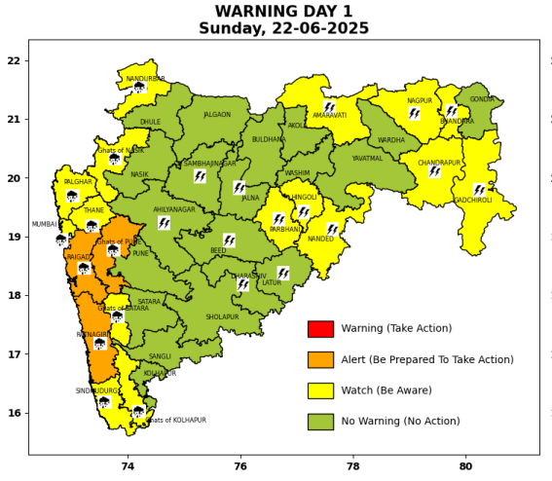 | 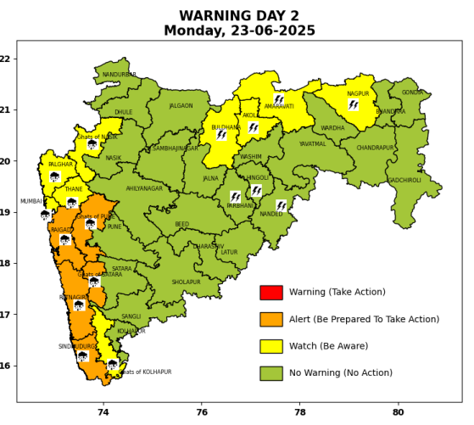 | 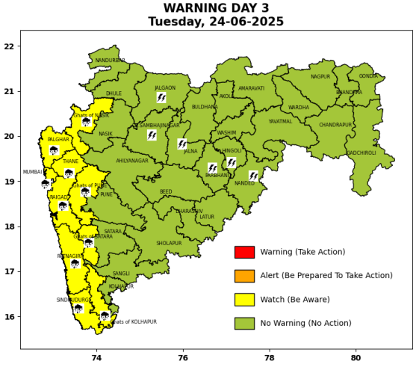 | 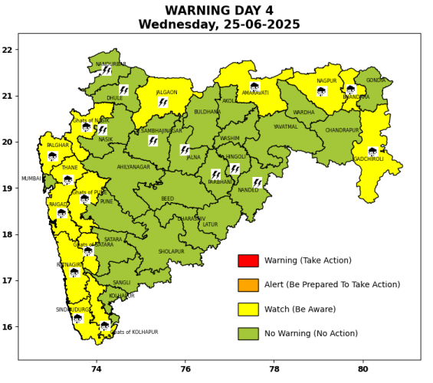 | 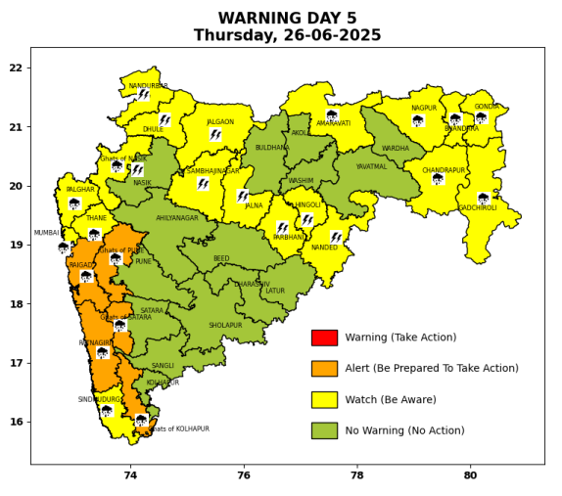

Pune, Lohegaon and Pashan observations at 0830 hrs. IST of Today
 | Temperature (°C) |  |  |  |  | Humidity (%) |  |  |  | Rainfall (mm)
 | Max.  past  24 hrs | Dep.  from  normal | Min.  past  24 hrs. | Dep.  from  normal | Dry  Bulb | At 0830 hrs. IST | Dep.  From  normal | At 1730  hrs. IST of y’day | Dep.  from  normal | Past  24 hrs. | Since  1st June | Dep.  from  normal
PNE | 29.2 | -1.2 | 22.5 | -0.5 | 25.4 | 78 | 0.0 | 71 | 1 | 2.9 | 241.1 | 132.4
PSN | 28.0 | - | 22.5 | - | 24.8 | 84 | - | 77 | - | 6.0 | 277.0 | -
LHG | 30.9 | -0.1 | 24.8 | 3.8 | 27.4 | 70 | -8 | 58 | -7 | 2.2 | 232.8 | 163.1

 |  |  |  |  |  |  | Local (Pune and neighbourhood) forecast
Max./Min. Temperature (°C) |  |  |  |  |  |  |  |  | Weather
Date | Pune | Pashan | Lohegaon | Chinchwad | Lavale | Magarpatta | NDA | Koregoan Park
22/06/25 | 30 / 22.5* | 29 / 22.5* | 32 / 24.8* | 29 / 22.7* | 29 / 22.2* | 31 / 24.3* | 29 / 23.5* | 30 / 24.0* | Generally cloudy sky. Light rain very likely.
23/06/25 | 29 / 23 | 29 / 23 | 31 / 25 | 30 / 23 | 28 / 23 | 31 / 24 | 30 / 23 | 31 / 24 | Generally cloudy sky. Light rain very likely.
24/06/25 | 29 / 23 | 29 / 23 | 31 / 25 | 30 / 23 | 28 / 23 | 31 / 24 | 30 / 23 | 31 / 24 | Generally cloudy sky. Light rain very likely.
25/06/25 | 29 / 22 | 29 / 22 | 31 / 24 | 30 / 22 | 28 / 22 | 31 / 23 | 30 / 22 | 31 / 23 | Generally cloudy sky. Light to moderate rain very likely.
26/06/25 | 28 / 22 | 28 / 22 | 30 / 24 | 29 / 22 | 27 / 22 | 29 / 23 | 29 / 22 | 30 / 23 | Generally cloudy sky. Light to moderate rain likely.
27/06/25 | 27 / 21 | 27 / 21 | 29 / 23 | 28 / 21 | 26 / 21 | 29 / 22 | 28 / 21 | 29 / 22 | Generally cloudy sky. Light to moderate rain likely.
28/06/25 | 27 / 21 | 27 / 21 | 29 / 23 | 28 / 21 | 26 / 21 | 29 / 22 | 28 / 21 | 29 / 22 | Generally cloudy sky. Light to moderate rain likely.
Rainfall Distribution |  |  | Rainfall Categories | Rainfall (mm) |  | Cloud condition |  |  |  | Rainfall Intensity |  | Range
Widespread (W) | 76-100% |  | Very Light rain | Trace to 2.4 mm |  | Mainly clear sky |  | 1-2 oktas |  | Light Spell |  | 1 cm/hr
 |  |  | Light rain | 2.5 to 15.5 mm |  | Partly cloudy sky |  | 3-4 oktas |  | Moderate Spell |  | 1-2 cm/hr
Fairly Widespread (FW) | 51 – 75% |  | Moderate rain | 15.6 to 64.4 mm |  | Generally cloudy sky |  | 5-7 oktas |  | Intense Spell |  | 2-3 cm/hr
Scattered (S) | 26 – 50% |  | Heavy rain | 64.5 to 115.5 mm |  | Overcast |  | 8 oktas |  | Very Intense Spell |  | 3-5 cm/hr
isolated (I) | 1 – 25% |  | Very heavy rain | 115.6 to 204.4 mm |  |  |  |  |  | Extremely Intense Spell |  | 5-10 cm/hr
D (D) | No Rain |  | Extremely heavy rain | ≥ 204.5 mm |  |  |  |  |  | Cloudburst |  | > 10 cm/hr
Probability Terms in %: |  |  | Heavy snow | 6.5 to 11.5 cms water equivalent of rain
unlikely | < 25 |  | Very heavy snow | 11.6 to 20.4 cms water equivalent of rain
likely | between 25 50
very likely | between 51 75
most likely | >75
* = realized temperature
Mumbai (Colaba) |  |  |  | Nagpur (AP)
Date 2025 | T max °C | T min °C | Weather | T max °C | T min °C | Weather
22/06 | 31 | 25 | Generally cloudy sky with intermittent heavy rainfall. | 38 | 26 | Generally cloudy sky with intermittent rain.
23/06 | 30 | 26 | Generally cloudy sky with heavy rainfall. | 38 | 26 | Partly cloudy sky.
24/06 | 32 | 26 | Generally cloudy sky with heavy rainfall. | 37 | 26 | Generally cloudy sky with intermittent rain.
25/06 | 31 | 25 | Generally cloudy sky with moderate rain. | 36 | 26 | Generally cloudy sky with intermittent rain.or thundershowers accompanied with Lightning.
26/06 | 30 | 24 | Generally cloudy sky with heavy rainfall. | 35 | 25 | Generally cloudy sky with intermittent rain.or heavy rainfall.
27/06 | 29 | 23 | Heavy rainfall. | 35 | 25 | Rain.
28/06 | 30 | 24 | Heavy rainfall. | 35 | 25 | Rain.

